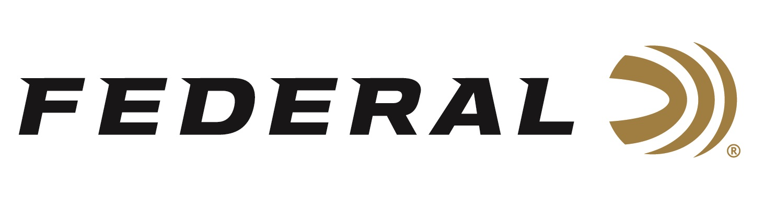

FOR IMMEDIATE RELEASE

Julie Golob, Modern Day Wonder Woman, joins the “It’s Federal Season” Podcast

ANOKA, Minnesota – May 14, 2020 – She sets shooting records. She has served the United States. She is on the front lines of protecting your 2nd Amendment rights. And that’s only half of the hats Julie Golob wears. Find out how she balances all her duties and the Federal products she uses and trusts on this episode of “It’s Federal Season.”

Episode No. 8 - Modern Day Wonder Woman
https://www.federalpremium.com/podcast.html

“I find Julie to be one of the most positive voices and leaders in the hunting and shooting industry,” says Jason Vanderbrink, President of Federal Ammunition. “Her passion for our industry is only surpassed by the energy she spends to improve people’s skills and knowledge about guns, ammunition, and proper technique.” This half hour is packed with her life story, influences, her accomplishments, and thoughts on how to maximize a day at the range as well as the importance of our 2nd Amendment rights. It is one of the best half hours of content found on any medium.

In the Tech Talk segment, Julie Golob stays on for a personal defense discussion with topics ranging from testing your CCW gear at home during the COVID-19 crisis to products she relies on and trusts in her guns. Before signing off, find out what promotions are available for consumers to buy Federal products and merchandise. Look for more episodes at www.federalpremium.com or where you find your favorite podcasts.

Federal ammunition can be found at dealers nationwide or purchased online direct from Federal. For more information on all products from Federal or to shop online, visit www.federalpremium.com.

Press Release Contact: JJ Reich
Senior Manager – Press Relations
E-mail: VistaPressroom@VistaOutdoor.com

About Federal Ammunition
Federal, headquartered in Anoka, MN, is a brand of Vista Outdoor Inc., an outdoor sports and recreation company. From humble beginnings nestled among the lakes and woods of Minnesota, Federal Ammunition has evolved into one of the world's largest producers of sporting ammunition. Beginning in 1922, founding president, Charles L. Horn, paved the way for our success. Today, Federal carries on Horn's vision for quality products and service with the next generation of outdoorsmen and women. We maintain our position as experts in the science of ammunition production. Every day we manufacture products to enhance our customers' shooting experience while partnering with the conservation organizations that protect and support our outdoor heritage. We offer thousands of options in our Federal Premium and Federal® lines-it's what makes us the most complete ammunition company in the business and provides our customers with a choice no matter their pursuit.

